**Problem statement**:

Given a directed labelled graph in form of a knowledge base, and a query, **write a parser** which can return the edges and/or nodes requested in the query. (Knowledge base and queries are **not** case sensitive)

Knowledge base is given as input in a text file (input.txt). Junit test cases are also provided to verify output (src/testparser.java).

For example a DAG can be represented as:

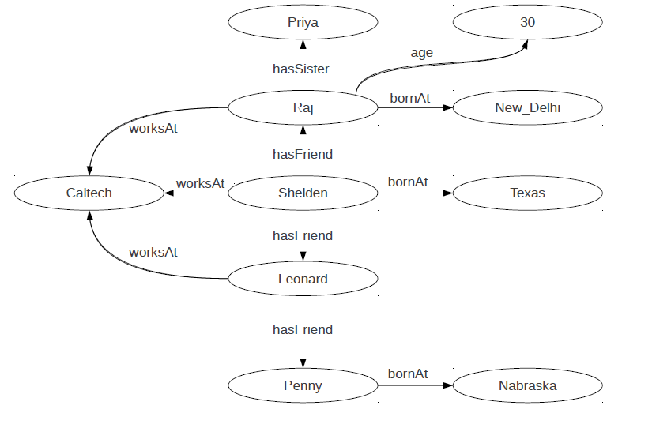

And the corresponding knowledge base for this DAG is :

(<Shelden>, <hasFriend>, <Raj>)

(<Shelden>, <hasFriend>, <Leonard>)

(<Shelden>, <worksAt>, <Caltech>)

(<Leonard>, <worksAt>, <Caltech>)

(<Raj>, <worksAt>, <Caltech>)

(<Raj>, <age>,“30”)

[Here 30 is a number and no edge can go out from this node while others like Nabraska, New_Delhi are entities, which can have further outgoing links.]

(<Leonard>, <hasFriend>, <Penny>)

(<Penny>, <bornIn>, <Nabraska>)

(<Raj>, <bornIn>, <New_Delhi>)

(<Shelden>, <bornIn>, <Texas>)

(<Raj>, <hasSister>, <Priya>)

A query can be written as :

Find persons who are friends?

**Test case 1 :** Select ?person1 ?person2 where { ?person1 <hasfriend> ?person2. }

The goal is to fill all the variable represented by ? with their values from knowledge base and return in csv format:

The result of this query is:

|  |  |
| --- | --- |
| Person 1 | Person 2 |
| Shelden | Raj |
| Shelden | Leonard |
| Leonard | Penny |

The similar query can be extended to have joins also:

Find persons who are friends with Sheldon and the company/colleges to which his friends belong?

**Test Case 2 :** Select ?person ?university where { <Shelden> <hasFriend> ?person . ?person <worksAt> ?university. }

|  |  |
| --- | --- |
| Person | University |
| Leonard | Caltech |
| Raj | Caltech |

**Test Case 3 :** Select ?person1 ?person2 where { ?person1 <worksAt> <Caltech> . ?person2 <bornIn> < Nabraska> . ?person1 <hasFriend> ?person2 .}

|  |  |
| --- | --- |
| Person 1 | Person 2 |
| Leonard | Penny |

**Test Case 4 :** select * where {?a ?b ?c.}

|  |  |  |
| --- | --- | --- |
| A | B | C |
| Shelden | hasFriend | Raj |
| Shelden | hasFriend | Leonard |
| Shelden | worksAt | Caltech |
| Leonard | worksAt | Caltech |
| Raj | worksAt | Caltech |
| Raj | age | 30 |
| Leonard | hasFriend | Penny |
| Penny | bornIn | Nabraska |
| Raj | bornIn | New_Delhi |
| Shelden | bornIn | Texas |
| Raj | hasSister | Priya |

**Test Case 5** : select * where {}

Output : Parse Error

**Test Case 6 :** select * where {?person2 <hasFriend> ?person2 . ?person 2 <worksAt>. }

Output : Parse Error